## Week 3 - Long Descriptive Questions

**1.What is a File system ? Explain the Linux file system with a diagram ?**

**Ans.** A file system stores and organizes data and can be thought of as a type of index for all the data contained in a storage device. These devices can include hard drives, optical drives and flash drives.

A file system defines how files are named, stored, and retrieved from a storage device.Every time you open a file on your computer or smart device, your operating system uses its file system internally to load it from the storage device. Or when you copy, edit, or delete a file, the file system handles it under the hood.

**Linus File System:**

The Linux File Hierarchy Structure or the File system Hierarchy Standard (FHS) defines the directory structure and directory contents in Unix-like operating systems. It is maintained by the Linux Foundation.

* In the FHS, all files and directories appear under the root directory /, even if they are stored on different physical or virtual devices.
* Some of these directories only exist on a particular system if certain subsystems, such as the X Window System, are installed.
* Most of these directories exist in all UNIX operating systems and are generally used in much the same way; however, the descriptions here are those used specifically for the FHS and are not considered authoritative for platforms other than Linux.

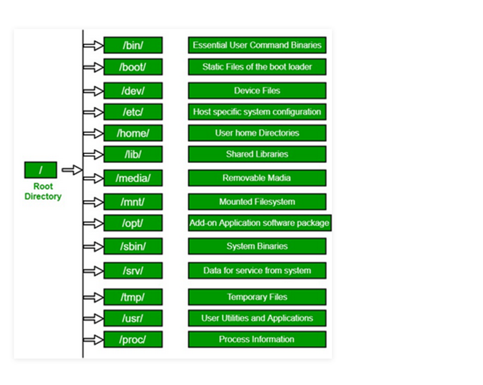

**2.Explain the dual modes of an Operating system ?**

Ans.

* **User Mode:**

· When the CPU is in user mode, programs can’t access memory and hardware directly.

· Moreover, if a program crashes in user mode, its effect is limited to that program only.

· Hence, the programs are in a safe state in this mode.

· Most of the programs are in user mode only.

· But whenever some privileged instructions, error handling, exception handling, hardware access or other hardware related access needs to be invoked, there is a switch from user mode to kernel mode.

* **Kernel Mode:**

· While the CPU is in kernel mode, programs can directly access the memory as well as hardware.

· All the privileged commands are executed in this mode only.

· Also, if a program fails in kernel mode then the entire system will halt.

· All the important library functions, subroutines etc. all are executed here only.

· Here user has nothing to do and the kernel only accesses the hardware to provide the requested service.

### Example

With the mode bit, we can distinguish between a task executed on behalf of the operating system and one executed on behalf of the user.

* When the computer system executes on behalf of a user application, the system is in user mode.
* However, when a user application requests a service from the operating system via a system call, it must transition from user to kernel mode to fulfill the request. As we can say, this architectural enhancement is useful for many other aspects of system operation.
* At system boot time, the hardware starts in kernel mode.
* The operating system is then loaded and starts user applications in user mode.
* Whenever a trap or interrupt occurs, the hardware switches from user mode to kernel mode, changing the mode bit's state to 0.
* Thus, whenever the operating system gains control of the computer, it is in kernel mode.
* The system always switches to user modeby setting the mode bit to 1 before passing control to a user program.

**3.What are system program ? Highlight few characteristics of it.**

Ans. System Programming can be defined as the act of building Systems Software using System Programming Languages. According to Computer Hierarchy, one which comes at last is Hardware. Then it is Operating System, System Programs, and finally Application Programs. Program Development and Execution can be done conveniently in System Programs. Some of the System Programs are simply user interfaces, others are complex. It traditionally lies between the user interface and system calls.

System Programs can be divided into these categories :

1. File Management –   
   A file is a collection of specific information stored in the memory of a computer system. File management is defined as the process of manipulating files in the computer system, its management includes the process of creating, modifying and deleting files.
2. Status Information –   
   Information like date, time amount of available memory, or disk space is asked by some users. Others providing detailed performance, logging, and debugging information which is more complex. All this information is formatted and displayed on output devices or printed. Terminal or other output devices or files or a window of GUI is used for showing the output of programs.
3. File Modification –   
   For modifying the contents of files we use this. For Files stored on disks or other storage devices, we used different types of editors. For searching contents of files or perform transformations of files we use special commands.
4. Programming-Language support –   
   For common programming languages, we use Compilers, Assemblers, Debuggers, and interpreters which are already provided to users. It provides all support to users. We can run any programming language. All languages of importance are already provided.
5. Program Loading and Execution –   
   When the program is ready after Assembling and compilation, it must be loaded into memory for execution. A loader is part of an operating system that is responsible for loading programs and libraries. It is one of the essential stages for starting a program. Loaders, relocatable loaders, linkage editors, and Overlay loaders are provided by the system.
6. Communications –   
   Virtual connections among processes, users, and computer systems are provided by programs. Users can send messages to another user on their screen, User can send e-mail, browsing on web pages, remote login, the transformation of files from one user to another.

Some examples of system program in O.S. are –

* Windows 10
* Mac OS X
* Ubuntu
* Linux
* Unix
* Android
* Anti-virus
* Disk formatting
* Computer language translators

**4.How are server systems classified? What is asymmetric clustering?**

**Ans.**

Server Operating Systems can be a basic for classifying the types of server or the web software running on it. A server can be classified based on the hardware infrastructure – like blade server, rack server etc. However, none of them appears to be constant and we classify the types of servers based on network environment.

**Types of Server : The usual Classification based on network environment**

* Application server : Server dedicated to run specific software applications
* Catalog server : Central point for a distributed network
* Communications server : Server acting as computing platform for communications network
* Compute server : Intended for intensive computations
* Database server : A server which only provides the database services to other computer programs or computers
* Fax server : A server for fax services for the clients
* File server : Provides remote access to files
* Game server : A server that is optimized to play online games together
* Name server or DNS Print server : An intermediary for requests from clients seeking resources from other servers
* Sound server : For streaming of sound over the Internet.

**Asymmetric Cluster:** In this type of clustering, all the nodes run the required applications, and one node is in hot standby mode. The Hot standby node is used for monitoring the server till it fails, when it fails then it takes its place.